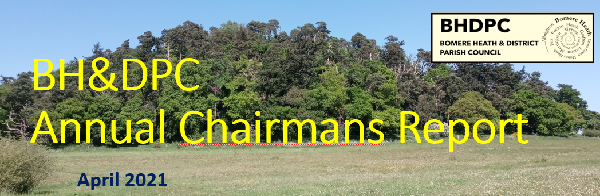
April 2023
Chairman’s Report – April 2023.
I would like to start my address by marking one of the most significant events for the country in 2022 by remembering the passing of her majesty, the late Queen Elizabeth.

This year feels more like the normality that we experienced pre-covid. The Parish Council has got back to the day to day running of business and I think it is important to reflect upon why we are here. It is our responsibility to do the best we can with the tools we have to try and benefit the community and create a nice environment to live in.

I would like the goals for the next 12 months to be.
- Environment,
- Progress
- & Wellbeing

I think the PC are embarking on positive steps to boost and benefit our environment, with the external support from the Severn Trent Green Recovery Scheme and the work that Alan has done with the RSVP with Middle Marches Community Land Trust to reinstate wild verges.

We must remember our function and continue wherever possible to add value to the Parish and use our funds appropriately. Good work has been made with the Business Plan and identifying sectors in the community that require our support.

Wellbeing is a key focus this year. We need to arrange the summer fete and early seed sewing has taken place, but I would like to see meetings happening to progress this with haste.

Once again, I wish to thank the Parish Council for its efforts during the last 12 months. As a parish council we have covered many key items, such as

Youth Club – year ago April that the PC was approached to renew the YC and I am pleased that the club is now up and running again with 25+ members and discussions about how to manage the new intake. The PC has committed to SYA support for another year, and this will significantly help.

Village Halls – We continue to support to the Fitz and BH Village Halls in their ventures and with maintenance for the more costly items.
We welcome to the new BH committee and were pleased to support them on their recent Flat roof funding. We also are pleased to assist Fitz in the acquisition of their land both with administrative financial support.

Galliers Estate – In May 2022 we had our meeting with Galliers planning consultant to review the options. The open event in Sept at the VH was well attended and the PC made a robust consultation review at the planning stage. I personally am hopeful that in the likely scenario that the development is granted their application that both the developer and the planners acknowledge our concerns and work with our community. It will be for the PC to follow this up.

Play Park – I think it is necessary to note that this year has yielded the greatest number of complaints of Anti-Social Behaviour from the play park. Our park has been the centre of issues and it has deeply affected a few of the closest residents. The PC will continue to work closely with the community to try and mitigate this behaviour. One of the key impacts to the BH Village is the closure of the Ball Park to the public. The PC need to prioritise a solution to create a place for the younger generation to play, be safe and feel it is a place of their own.

Ball Park (Primary School) – As just noted, we have received confirmation from the Primary School that they have withdrawn the use of the Ball Park from general community use. The PC are unable to agree to the terms of the lease and we are at an impasse. It is right that we conclude the matter and seek alternative solutions moving forward. The PC has approached a local landowner to see if a Ball Park could be located near to the new development should the application be approved.

Bus Stop- I thank Cllr Keogh for his continued pressing on the Bus Stop matter. We are hoping that this will be in place in the summer.

The Queens Platinum Jubilee Beacon Celebration – I would like to thank Leaton Estate and the Community for their support of the QPJB in June. It was well supported by the PC and the event was well received in the community.

The Parish Council has reviewed many planning applications during the last 12months.
I will advocate that the PC follow applications post completion and ensure that drawings and plans are completed in line with the application and areas that developers are due to maintain are completed.

I am pleased to report that the Finances of the Parish Council are strong, the PC finance committee met in Feb to monitor against the budget set. We have made some changes including updating the IT for the clerk. The Cost to run the PC is estimated to be around £29k for 2023/24. This is an increase on the projected figures and less than the precept will yield. But we have the funds to sustain it for this year.

The PC precept has been held at 0% to try and soften other cost of living impacts to the community.
We do have a modest sum set aside in our annual budget for local community groups/activities/events funding. Should there be a requirement for financial assistance, please fill in the grant application form on our website and email the clerk for us to consider.

& Forton Heath EOI – 2023 needs to be the year that we see works carried us at Forton. The PC will be pressing SCC with Cllr Pictons’ support.

Councillors
The last 12 months we said goodbye to Cllr Martin Speak; he retired in February because he was moving out of the area.

In closing, I would like to thank.
Shropshire Cllr Lezley Picton for her continued support throughout the year.
And as always, our Clerk Sue Horton for her hard work in assisting and supporting the PC.

Lastly, I thank the parishioners, those that engage with the Parish Council and interact are very helpful. It is sometimes hard to make decisions with the best interest of the Parish, this is made much easier when we have an idea of what is important to you. We continue to encourage your feedback, both positive and negative where appropriate. Your feedback and interaction are valued and hopefully our actions reflect the majority view in the parish.

Many Thanks
Dan Harmer
Chair – Bomere Heath Parish Council

