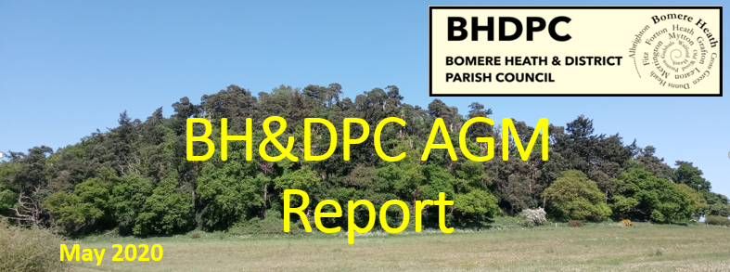
Chairman’s Report – May 2020. Dan Harmer
I feel that my Second year as Chair has been another successful one, albeit we have had an unusual last few months. This report has been written during the Coronavirus/Covid 19 Pandemic that has seen the UK and the world take extreme lock down measures. Normally this report would be prepared for the April AGM, however, this year our AGM has had to be postponed and our normal meeting cancelled. The PC decided to have a scaled back Finance Committee meeting via Video Conference. This is believed to be the first of its kind in our PC history and looks like it won’t be the last. SCC is still operational and Finance and Planning matters still require our attention, so we needed to discuss some critical items.
The May meeting would ordinarily be the month that candidates would be elected into roles and we would set out the plan for the forthcoming year. Due to the pandemic, this May we will hold a full PC Video Conference Meeting and the proposal is currently that the roles will remain as per 2019 for the forthcoming year.

The parish council has continued the good work following the results of the 2017 Community Led Plan (CLP) report. I can elaborate on the progress of the following CLP topics;
Bomere Heath Youth Club is going strong and completed its first successful year in January, the club averages 25 members a week. This was one of the primary objectives of the CLP and we thank the Youth Club team for their continued support.
One of the biggest successes of 2019 was the Parish Fete. This was led by several Councillors and a committee of local people, it was a huge effort by everyone involved and really was a coming together of the community to make such a fantastic day. The plan was to make 2020 bigger and better, but sadly due to the Coronavirus, we have taken the decision to postpone this until we would be able to run one again safely.
Benches were reviewed in detail and we have agreed to continue to maintain 5 of the 6 benches and refurbish or replace the bench on the Merrington top road by the STW reservoir.
Social Media. We have continued to grow the PC website and have now introduced a BHPC Facebook page to aid communication within the parish. We have had some very good feedback so far.
Local Funding. I am pleased to say that we have been able to support the parish by funding some local projects, including AED Phone Line& Parish News. This year we donated a £4000 contribution to Fitz Village Hall to refurbish their floor
Traffic and Speeding have been progressed, with a community speed camera and progressed discussions with SCC, Highways and the Police about Forton Heath. However, since Lockdown these discussions have paused.
We are continuing to review housing (In the form of Place Planning), local infrastructure and are also embarking on a Coronavirus Support Group. I pay tribute to those Councillors and Parishioners that have been able to step up and help the most vulnerable in our community. This is a testament to the tenacity and diversity of our Parish Council, being able to establish and maintain a support network at such short notice that really benefits those in need.

I am pleased to report that the Finances of the Parish Council are strong, the PC finance committee has met several times to monitor against the budget set and using the CIL funds have started to progress the “Big Idea”, a large scale community project. At the business planning meeting in January, this was scheduled for spring 2020, but due to the lockdown situation this has been paused for the time being. Proposals will include the refurbishment or replacement Village Hall in Bomere, a parish cycle path or multi age and ability exercise area, or even investigating purchase of or management of the Zion Church as a community asset following its closure earlier this year. Currently there is no certainty, but these are things that we will pursue after lockdown.
As mentioned previously, this will take dedication and commitment from the PC and external expertise, along with support from members within the parish on a dedicated committee.
The PC agreed that the 2020 precept (the money that the PC gain from Council tax payments) will be increased. This is for the first time in over 6 years. The purpose is to balance our regular outgoings that have increased due to cost of living increases. This increase, which was just over a pound, prevents us needing to dip into our savings.
As part of financial review, I proposed and the PC agreed that the fixed annual donation of £100 to 11 chosen charities will now cease. We were the only parish council that do this and as we now are working towards a Parish amenity and this will strengthen our financial position.

2019 saw a few IT modernisation upgrades. We now have an electronic data storage and control facility. This will aid our ability to retain valuable information and details for future generations. We also have an email facility that maintains some continuity for the PC and saves multiple email addresses and the burden being placed on individual councillors to sort.

In connection, we have discovered nearly 100years of minutes belonging to the Parish Council dating back from 1913. This has been a fascinating find and offered a real insight into previous Parish Council member’s decisions.
One fantastic find is that the PC was gifted a piece of land on Broomhall Lane in 1979 which was turned into a Parish woodland that was going to be progressed into a Parish walk and recreational area. This land has been subject of hearsay for many years, but we have now established that the solicitor used at the time has the deeds. We will debate how best to use this for us in the coming months. The minutes discovered will be deposited at Shropshire Archives and digital copies produced for display on our website as soon as we are able to.

I wish to recognise that during the last 12 months Bomere Heath has seen the completion of Hayward Close (by Meres and Mosses & developer TC Homes), as well as the completion of the new estate off Whitehouse Lane (by Galliers). We welcome all new residents to our Parish.

What’s next for 2020?
North West Relief Road will likely be decided upon this year and we will have a better idea on the outcome and the plans moving forward.
Smart Water – The PC has agreed to finance and roll out the Smart Water household protection system. This will be processed in our parish as soon as lock down permits.
Environmental Matters – The PC together with SCC and a small team of members from the parish will review what sustainable and environmental ideas that we could adopt in the community.
Footpath Monitoring – I am aware that in the past the PC would have carried out an independent check and log of the Parishes footpaths, it is my hope that we can pick this back up as a PC and report in to SCC’s Outdoor dept. and keep good up to date records ourselves including an annual report every Sept/Oct.

The last 12 months has seen a change in the PC, we have had 3 new councillors and 1 resignation
- June Jex - Sept
- Martin Buxey - Oct
- Feb - Andy Cassidy (Who due to the Corona-virus cannot be elected at this time)
We received the resignation of Cllr Rob Cook, in November

I would like to thank Rob for his many years’ of service and dedication whilst being on the Parish Council. This does leave a vacancy on the Parish Council and straight from last year’s report, “I wouldn’t be doing my position justice without again calling for volunteers to stand for the PC in the coming year.” We have a one space available.

Before my final thanks, I would like to take a moment to remember Cllr Eric Baker who sadly lost his battle to cancer last year. I hope that we as a PC can find the right moment and tribute to act as a fitting commemoration to him in the future.

Lastly, I would like to thank the members of the Parish Council for their continued efforts and support of the local community. In spite of the Coronavirus and the challenges that it poses I feel that in 2020/2021 we can again continue to make a difference and push forward with our ambitious plans to make our community a stronger and even better one to be a part of.

In closing, I would also take this opportunity to thank Vice Chair Mrs L Cowley, Cllr Lezley Picton and our Clerk Sue Horton for your continued efforts to assist and support the PC and give a mention of thanks to Mathew Mead from SCC for his support.

Many Thanks
Dan Harmer
Chair – Bomere Heath Parish Council

Attendance chart for 2019/2020.

