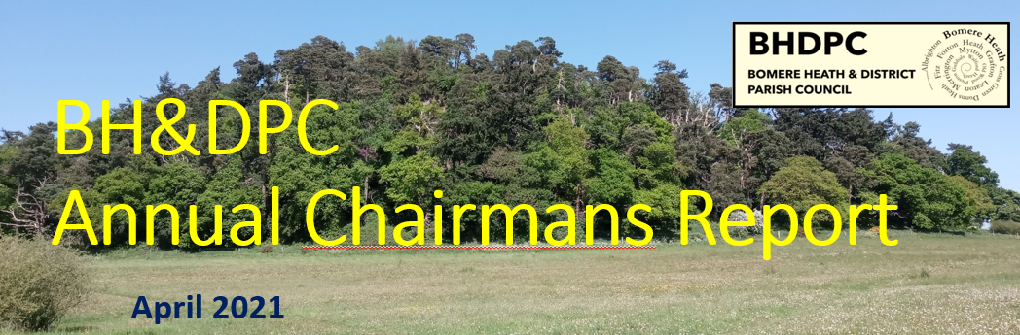
Chairman’s Report – April 2021. Dan Harmer
I have to say, my third year as chairman has been like no other. I wish to start by thanking the Parish Council for their determination and hard work throughout this unprecedented year.
The Parish Council has continued through the year, meeting via video call and continuing to serve our local community and working on local matters that are still as important as ever. For this I thank them all.

Many businesses and local groups have suffered during the pandemic, including our local pub the Red Lion, the youth club, the cubs/scouts & beavers and many other groups where meetings have not been permitted. Equally I would like to commend local organisations such as BH Primary School, Surecare and the Co-op for continuing to provide through lockdowns.
The year has sadly seen many events cancelled including the Xmas dinner dances, the Gardeners club show and even our own Fete was not able to run. I image that many of these events will sadly not happen to the full extent in 2021, but hopefully meetings will be permitted and planning for events in 2022 will be renewed later this year.

Despite the pandemic and the restrictions, the parish council has managed to continue elements of our CLP (Community Led Plan) agenda and respond to other community issues that were raised.
The main items covered this year are as follows;
Smart Water – In April we teamed up with the West Mercia Police using funding from the Police and Crime Commissioners office to post smart water kits to every occupied household in the parish. This was successfully completed and the accompanying signage has now been installed throughout the parish.
By now we would expect that every household has been able to mark their valuables (Please not forgetting items in the sheds and outbuildings) The other main deterrent is placing a sticker in a window, so it is visible.
The Parish Fete - One of the biggest successes of 2019 was the Parish Fete. It was a huge effort by everyone involved and really saw a coming together of the community to make such a fantastic day. The plan was to make 2020 bigger and better, but sadly due to the Coronavirus we agreed to postpone. It has been agreed not to run a fete in 2021, but the hope is that in the autumn we can plan for the Fete in 2022.
Traffic and Speeding – the main area of focus was again Forton Heath. In May we were able to meet on site at Forton Heath with the Police and Shropshire Highways. The PC has secured significant funding from SCC and we Shropshire Highways Engineers are now working up a strategy taking our requests and that of the local residents to introduce a speed limit and traffic calming measures.
Huffley Lane – Huffley Lane has seen the new traffic calming measures installed and the parish has had many roads resurfaced through last summer and autumn.
Potholes – SCC and our own councillor Lezley Picton have acknowledged that the general conditions of the roads in Shropshire are sub-standard. There have been several issues with potholes in the parish. The PC has been logging issues onto My Shropshire and we would encourage the general public to do so. There has been a very significant issue in Fitz/Mytton that Councillor Briers has been championing with Highways and this is still ongoing.
Coronavirus Support Group - I again thank and pay tribute to those Councillors and Parishioners that have been able to step up and help the most vulnerable in our community. This was launched in the first lock down and though not needed as much in the latter lockdowns the support is still available.
Rights of Way – Throughout lockdown our parish footpaths have been well used. There have been some instances where the walkers with dogs have upset cattle and others have inadvertently strayed off the footpath and damaged verges which are protected for wildlife. I encourage everyone to look at the information that we have posted on the website.
Social Media - We have continued to update and expand the PC website and the grow the BHPC Facebook page. This has been a valuable tool to aid communication within the parish. I would encourage parishioners to join our page for updates.

The Parish Council has reviewed many planning applications during the last 12months. We will continue to review and respond as they are issued from the planning dept. Our website has guidance and alerts generated directly from the planning dept.

I am pleased to report that the Finances of the Parish Council are strong, the PC finance committee have met virtually this year to monitor against the budget set. We have made some changes including the termination of and old account that is no longer required and enhancing the PC’s digital access to our accounts. This enables better control and reduces the need to visit branches.
The PC precept has been kept the same as 2020. We felt that due the pandemic that we would not increase our council tax request based on the year that we have had.
Electricity Bills – We have spent considerable time engaging with Western Power and N Power and this year it has paid off. Our running costs for streetlights have now almost halved from £650 per quarter to an average of £325. This is due to the 2018 LED light installation and a lot of work updating the supplier information.
The PC pay for an annual safety checks on the Play Park and this year is the first year that the Play Park has incurred maintenance costs in the region of £1000. The works were carried out and the park is safe to use.
Expression of Interest – Many thanks to Cllr Cowley and Mathew Mead of SCC in applying for and obtaining funding that will allow the PC to carry out the speed restriction and traffic control measures in Forton Heath.
Zion Chapel & BH Village Hall - I wish to reflect on one of the biggest undertakings that we have made in the recent past by noting the hard work that has gone in regarding the opportunity about purchasing the Zion Chapel. The PC has been reviewing a “Big Idea” for some time. We had a one-off opportunity that was offered, to purchase the Zion Chapel. The PC undertook an exercise of community engagement to gauge support. This engagement happened to re-opened past discussions with the Village Hall and the general lack of responses to the Chapel purchase and the ability to work with the Village Hall meant that the PC have decided not to proceed with the Zion Chapel and look at working with the VH Committee.
I am pleased to say that there has been a great deal of offers of support from the engagement and any undertaking to refurbish or update the Village Hall will take time and support, so any offers will be appreciated.
Community Lottery - In November the PC had a majority vote to introduce a community lottery to the Parish, this would bring modest funds that could be used in any project such as the chapel. We have since agreed not to introduce this until there is a scheme set up that could benefit from the funds. All being well the PC will be able to work with the Village Hall and then this could be re-introduced at a later date.

What’s next for 2021?
Environmental Matters – The PC together with SCC and a small team of members from the parish will review what sustainable and environmental ideas that we could adopt in the community.
Right House / Right Place – A council initiative is underway to ensure that the Right House/Right Place is shared amongst the community. This may be in the way of a questionnaire or public consultation later in the summer. The feedback will help the council planners and policy makers plan for future development throughout Shropshire.
Village Hall – As already mentioned there is a lot of work to do to work with and assist in funding the Village Hall
Forton Heath – Progressing the works at Forton Heath with Highways

The last 12 months has seen a change in the PC, we have had 4 resignations
- June Jex - September
- Jason Buglass - November
- Martin Buxey – January
- Owen Evans –April - Owen has chosen not to re stand in the May elections

I would like to thank June, Jason, Martin and Owen for their service. Particularly Owen who has served on the council for many years.
One of the frustrations of the pandemic is that we have not been able to co-opt any new Parish Councillors, however, from February 2021 we are once again able to welcome new members (in a socially distant way). This does leave several vacancies on the Parish Council and if you are able to volunteer, we would welcome the support. It is a worthwhile benefit and you have an opportunity to impact your community for the better. We need numbers to be able to remain effective, If you feel that you can help, please contact the clerk.

In closing, I would like to thank;
Shropshire Cllr Lezley Picton for her continued support throughout the year,
Clerk Sue Horton for your hard work in assisting and supporting the PC.
PC Ross Cookson of the SNT for his input into the parish
The above are a valuable support and really help the PC to function effectively.
Lastly I thanks the parishioners, those that engage with the Parish Council and interact are very helpful. It is sometimes hard to make decisions with the best interest of the Parish, this is made much easier when we have an idea of what is important to you. We continue to encourage your feedback, both positive and negative where appropriate. Your feedback and interaction is valued and hopefully our actions reflect the majority view in the parish.

Many Thanks
Dan Harmer
Chair – Bomere Heath Parish Council

Attendance chart for 2020/2021.

