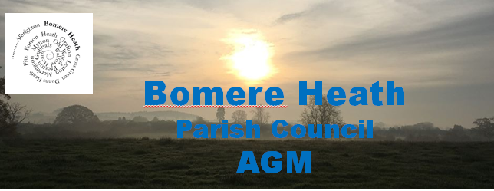
Chairman’s Report – April 2019. Dan Harmer
My first year as Chair has been a challenging but extremely productive one. Challenging, because it’s hard to continually strike the right balance between listening to community concerns/issues and actually pushing through the red tape to make a difference. However, very productive, because as a PC we are making difference and have a real opportunity to do so much more.

The parish council has continued the good work following the results of the 2017 Community Led Plan (CLP) feedback.
This year has seen the start of the Bomere Heath Youth Club, one of the primary objectives of the CLP was to form a youth club for children 10 – 15. This has been a resounding success and I thank all those involved in getting it started.

The PC has made investigations into allotments and discussed the potential for a bowling green at the Cricket Club. In addition we have debated how to deal with the two most complained about topics, Speeding and Dog Mess.
As a result we have financed 2 additional dog bins that should be in place later this spring. We are currently investigating how to best combat speeding within the Parish. We have been in discussions with Baschurch PC and are currently looking at the benefits around flashing speed signs. These are around £2000 per sign and will take a small committee of volunteers to manage moving them and downloading the information on a monthly basis.

Other parish involvements have been on numerous planning applications, doing our best to interpret the comments from the CLP and ensure that the applications are in keeping with the area and the local needs. The Parish has seen developments in Walford, Forton and Bomere. As a PC we have listened to the residents of Walford and agreed that we would actively reject any further request for development, should any applications be made. We have also seen 2 new estates in Bomere commence.
Our challenge moving forward is to work with Shropshire Council in the ongoing Local Plan Review (LPR) to plan where future developments between now and 2036 will be sited. We accept that some will be necessary and have selected the site south of the new 34 houses and North of the football pitches.

Projects that the PC will be working on this summer include upgrading and new benches within the Parish and acquisition of the local patch of land and the potential for a bike/scooter track.

We have continued to grow the PC website and have now introduced a BHPC Facebook page to aid communication within the parish. We have had some very good feedback so far.

Finances of the Parish Council are strong, the PC finance committee has met several times to form the budget for the next 12 months and using the CIL funds start to plan the “Big Idea”. The “Big Idea” as we are calling it will be a large scale community project that will have a lasting positive impact within the Parish. I am an advocate for, for example, an upgrade/refurbishment of the BH Village Hall, a parish cycle path or a multi age and ability exercise area.
This will take dedication and commitment from the PC and in my opinion, external expertise along with support from members within the parish on a dedicated committee.

I am pleased to say that we have been able to support parish by funding some local projects, including AED Phone Line& Parish News. In addition and in line with the CLP option have now agreed a fixed annual donation of £100 to 11 chosen charities. All this has been done without raising the precept allowance in council tax bills for a 3rd year running.

What’s Next …
We are working with the Friends of Bomere Heath Primary School to arrange a Community Party, this will hopefully involve several elements and groups within the parish and allow groups to showcase their organisation and fundraise at the same time as the community coming together. More information on this to follow shortly.

Sadly we have received 3 resignations in the past 12 months;
- June – Mr E Baker retired due to ill health. Mrs B Alexander resigned
- Nov – Mr N Baly retired
We thank Eric, Bev and Neil for their service and input whilst being on the Parish Council. This does leave some vacancies on the Parish Council and I wouldn’t be doing my position justice without again pleading for volunteers to stand for the PC in the coming year. We have a PC of 10 and can host 13 in total.

Lastly, I would like to thank the members of the Parish Council for their continued efforts and support of the local community. I feel that in 2019/2020 we can continue to make a difference and complete the next phase of actions from the CLP. I would also take this opportunity to thank Cllr Lezley Picton and our Clerk Sue Horton for your continued efforts to assist and support the PC.

